USER MANUAL
Digital Read Out with RS485 Output (MOD-BUS)

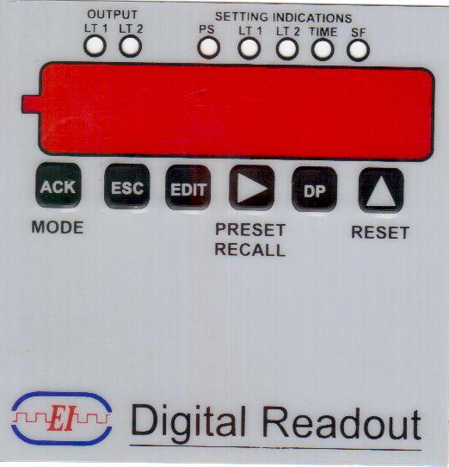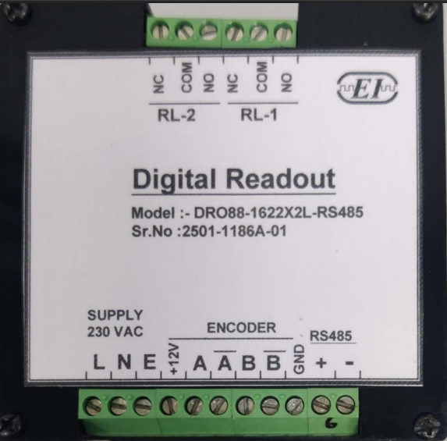

Front View Back View
FEATURES:
It counts the incoming pulses, multiplies counts with specified scale factor.
Device maintains its parameter and state of Output in case of power failure.
SPECIFICATIONS:
DISPLAY : Six Digit Seven Segment Display, Red Colour
SENSOR: Rotary Encoder with Two Channels
SUPPLY: 24V DC + 15%
DIMENSIONS: (W x H x D) (96 x 96 x 110)mm
PANEL CUTOUT: (92 x 92)mm
MEMORY BACKUP : Non- Volatile

Abbreviations:
ACK : Acknowledge .To Save Current Configuration.
SF : Scale Factor (As per formula given below)
PS : Pre-set Value (000000 – 999999), set by pressing pre-set/recall key.
DP : Dot Point
Reset : Count can be reset to zero and all outputs switched off.
S.F. : Scale factor
LT : NOT USED
Protocol Setting for Serial Output :
Bit Per Second(BPS) : 9600
Data Bits : 8
Parity : None
Stop Bit : 1
Flow Control : None
PAGE 1OF 3
Working:-
MODE/ACK: This key is used to save the current configuration for corresponding parameters. Press Key for 2 Sec it will move to Programming Mode. To move to setting Indication press mode key till it selects the required Parameter of setting Indication.
Esc. : This key is used to clear the previous reading.

EDIT : To edit the parameters press the mode key to select the required parameter and then press Edit Key.

INC/RESET: In normal running mode this Key is used to reset the current counts to zero (counts=0)
Increments the selected digit value from 0-9 when in configuration mode.

DOT POINT: This Key is used for dot point setting. To change the position of Dot Point, press Dot point Key, the corresponding Led will glow. Then select the position of the Dot point as
required
Example : If you want to have decimal point in second place then dot point should be 0.00

SHIFT/PRESET RECAL: In normal display mode this key will display (000000)Press Key, the corresponding Led will glow and the previous stored Value will display. The value will move from the value saved in PS

Scale Factor : The formula to calculate the scale factor

Scale factor = Reading required per revolution
4 x PPR of encoder
Example:

Suppose we have a 500 PPR encoder and we want the reading per revolution to be 500
Scale factor = 500 = 000.250 OR we can feed 0.25000 for better calculations.
4 x 500

Similarly with a 500 PPR encoder to DISPLAY a reading of 20/rev : scale factor = 0.01

LIMIT : When this key is pressed for more than 3 second user is able to enter the Limit mode. The corresponding Leds will glow. Now enter the value for Limit1 and press ACK Key to save the Limit1 value. After Pressing Ack. Key user will be in Limit 2 configuration mode, Enter Limit2 Value, again press ACK Key to save Limit2 Value and to enter running mode.

Example : Limit 1(LT1) = 100 Limit 2 (LT2) = 200, Timing = 00
Set LTI=100 When the count read 100 then Limit1 operate and the Led LT1 will glow.
Set LT2=200 When the count read 200 then Limit 2 operate and the LT2 will glow and both the Relays operate & Leds will glow till the RESET . This mode is Latching Mode

Example : Limit 1(LT1) - 100 Limit 2 (LT2) -200 Timing = 1Sec to 10 Sec
Set LTI-100 and Ack and Set LT2-200 and Ack & time 1 Second & Ack. When the count will read 100 the Relay 1 operate & Led LT1 will glow and when the count reads 200 Relay 2 operate & LT2 will glow and both the Relay operate & Leds will glow till 1-sec. This is Monoshot mode.
PAGE 2 OF 3

Protocol Setting for Modbus DRO :
Holding Registers
40001 : read/write the value lower 16 bit
40002 : read/write the value upper 16bit
40003 : read the address of node
40004 : Change the address of node
baud rate : 9600
word length : 8
parity : none
stop bit : 1
Address : 127 (Master address)

Setup :
1. Connect the DRO with computer with RS-485 using USB to RS-485 converter.
2. Open Mode Scan
3. Select Device ID 127, Length 4, holding register.
4. Click on connections connect. New window will be open.
5. Select comport, baud rate 9600, word length 4, parity none and stop bit as 1.
6. you will get the DRO value in address 40001 and 40002 in hexadecimal.
7. To reset the counts write 0 in address 40001 and 40002
8. Device ID shown in the address 40003 of that particular node.
9. Device ID can be changed by click on address 40004.
10. Convert the hexadecimal value to decimal that is displayed on the DRO.
11. Range of DRO is 0 to 999999(F423F in Hexadecimal).

Note:- To change the address and 1st time communication. Connect 1 pc at a time.
PAGE 3 OF 3

